ProjectPlanningPhase

ProjectPlanningTemplate(ProductBacklog,SprintPlanning,Stories,Storypoints)

|  |  |
| --- | --- |
| Date | 22October2022 |
| TeamID | PNT2022TMID48131 |
| ProjectName | Inventory Management System forRetailers |

ProductBacklog,Sprint Schedule,andEstimation(4Marks)

Usethebelowtemplatetocreateproductbacklogandsprintschedule

|  |  |  |  |  |  |  |
| --- | --- | --- | --- | --- | --- | --- |
| **Sprint** | **Functional**  **Requirement(Epic)** | **User StoryNumber** | **UserStory/Task** | **StoryPoints** | **Priority** | **TeamMembers** |
| Sprint-1 | Registration | USN-1 | As a user, I can register for theapplication by entering my email,password,andconfirmingmy  password. | 2 | High | 4 |
| Sprint-1 |  | USN-2 | As a user, I can register for theapplicationthroughE-mail | 1 | Medium | 4 |
| Sprint-1 | Confirmation | USN-3 | Asauser,Iwillreceiveconfirmation  email once I have registered for theapplication | 2 | Medium | 4 |

|  |  |  |  |  |  |  |
| --- | --- | --- | --- | --- | --- | --- |
| **Sprint** | **FunctionalRequirement(Epic)** | **User StoryNumber** | **UserStory/Task** | **StoryPoints** | **Priority** | **TeamMembers** |
| Sprint-1 | Login | USN-4 | As a user, I can log into theapplication by entering email &password | 2 | High | 4 |
| Sprint-2 | Dashboard | USN-5 | As a user, I can view the productswhich areavailable | 4 | High | 4 |
| Sprint-2 | Additemsto cart | USN-6 | As a user, I can add the products Iwish tobuytothe carts. | 5 | Medium | 4 |
| Sprint-3 | StockUpdate | USN-7 | Asauser,Ican add products which  arenotavailableinthedashboardtothestocklist. | 5 | Medium | 4 |
| Sprint-4 | Request toCustomerCare | USN-8 | As auser,Ican contact the  CustomerCareExecutiveandrequestanyservicesIwantfromthecustomercare. | 5 | Low | 4 |
| Sprint-4 | Contact  Administrator | USN-9 | IcanbeabletoreportanydifficultiesIexperience as areport | 5 | Medium | 4 |

ProjectTracker,Velocity&BurndownChart:(4Marks)

|  |  |  |  |  |  |  |
| --- | --- | --- | --- | --- | --- | --- |
| **Sprint** | **Total StoryPoints** | **Duration** | **Sprint StartDate** | **Sprint End Date(Planned)** | **Story PointsCompleted (ason PlannedEndDate)** | **Sprint Release Date(Actual)** |
| Sprint-1 | 7 | 6 Days | 24Oct 2022 | 29Oct 2022 | 7 | 29Oct 2022 |
| Sprint-2 | 9 | 6 Days | 31Oct 2022 | 05Nov2022 | 9 | 05Nov2022 |
| Sprint-3 | 5 | 6 Days | 07Nov2022 | 12Nov2022 | 5 | 12Nov2022 |
| Sprint-4 | 10 | 6 Days | 14Nov2022 | 19Nov2022 | 10 | 19Nov2022 |





**Velocity:**

|  |  |  |  |
| --- | --- | --- | --- |
| Sprints | SprintDuration | Velocity | ActualVelocity |
| Sprint-1 | 6 | 7 | 0.85 |
| Sprint-2 | 6 | 9 | 0.66 |
| Sprint-3 | 6 | 5 | 1.2 |
| Sprint-4 | 6 | 10 | 0.6 |

BurndownChart:

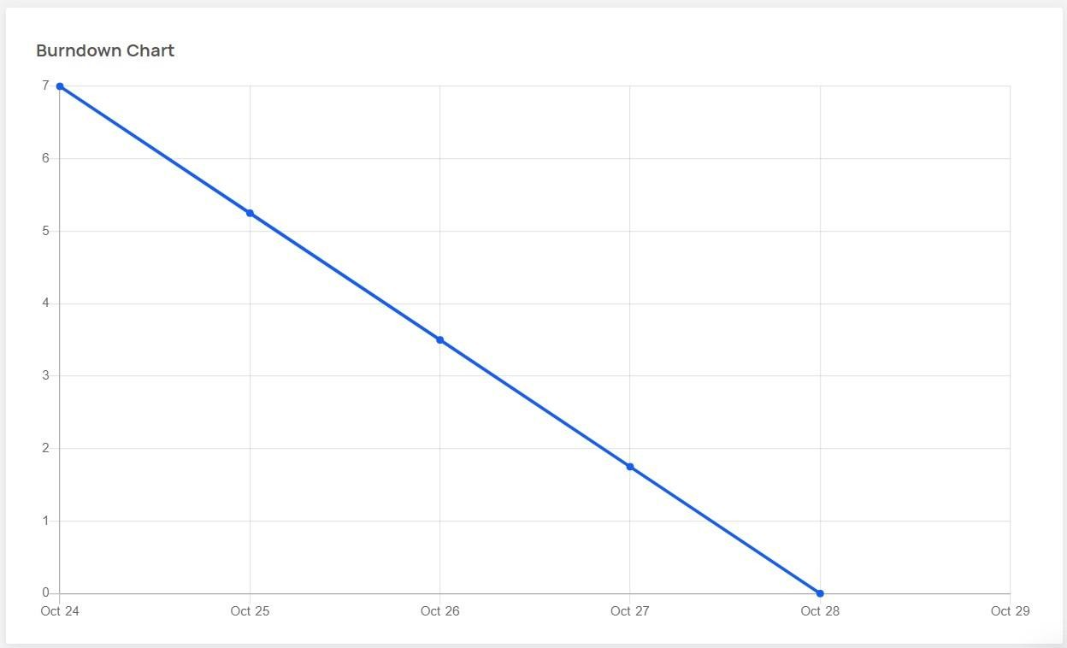

Sprint- 1

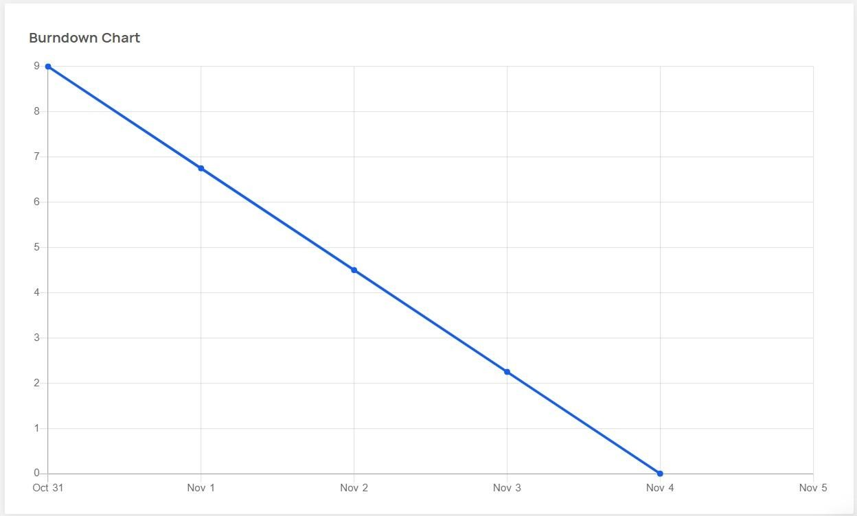

Sprint–2

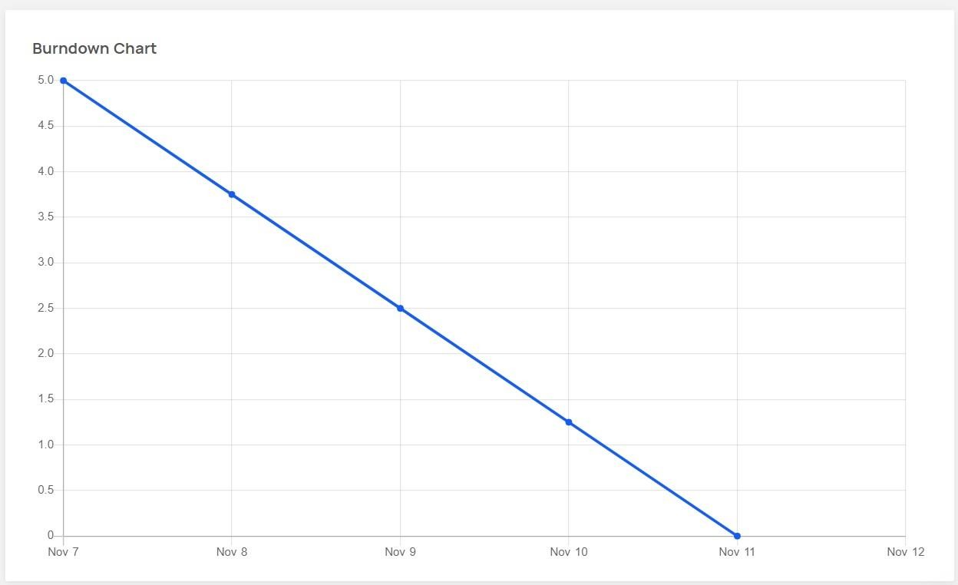

Sprint- 3

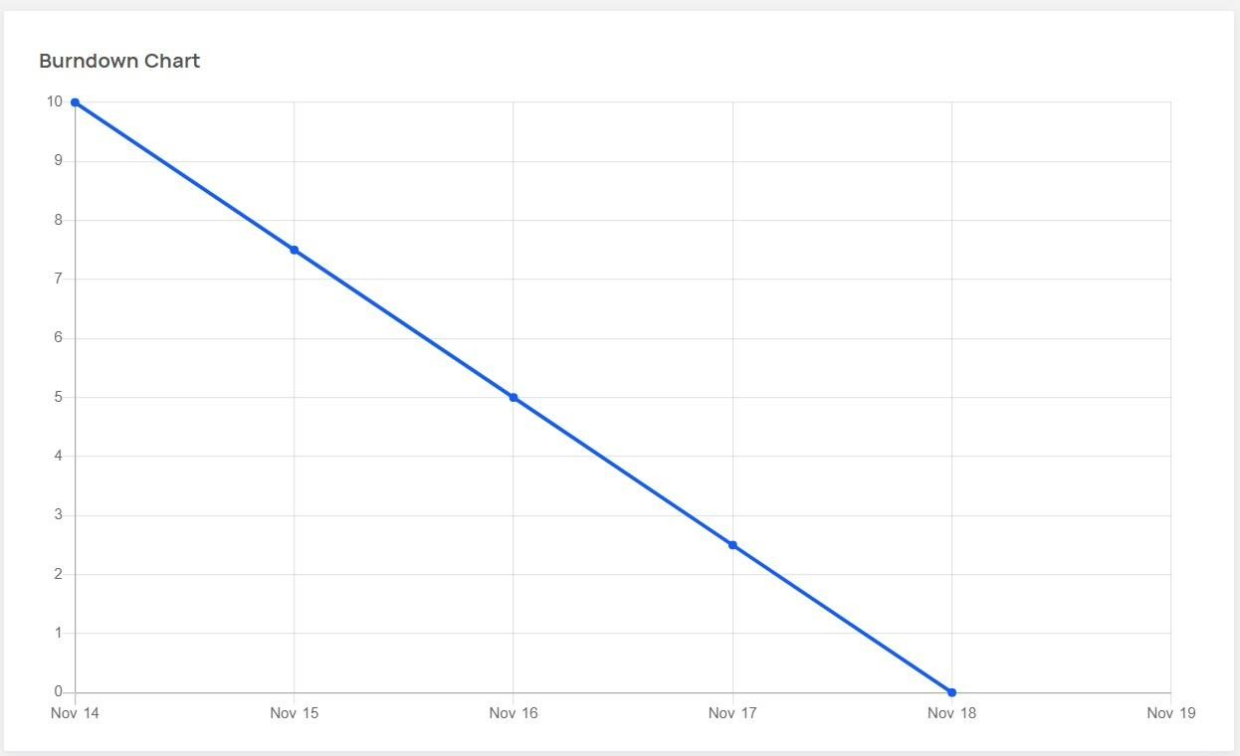

Sprint–4

ProjectTool:JIRA

